Chapter 6, Solution 20.

Consider the circuit shown below.

C₁

C₂

C₃

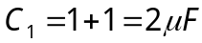
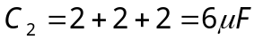

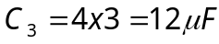

1/C_{eq} = (1/C₁) + (1/C₂) + (1/C₃) = 0.5 + 0.16667 + 0.08333 = 0.75x10⁶

C_{eq} = 1.3333 µF.

